A000-Asia-China-Bronze-W Han-Ding-206BCE- 24CE

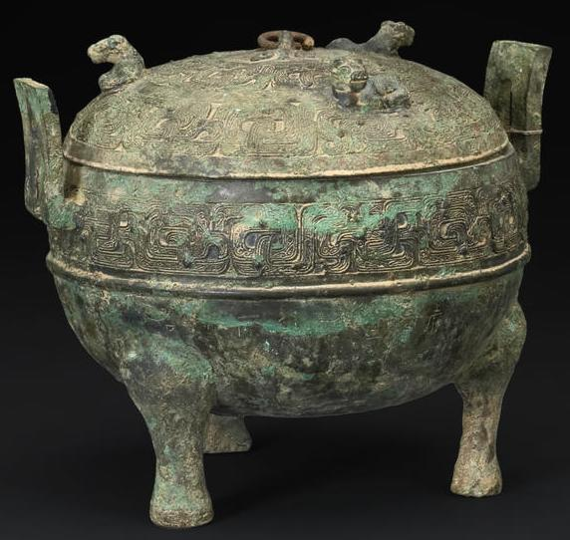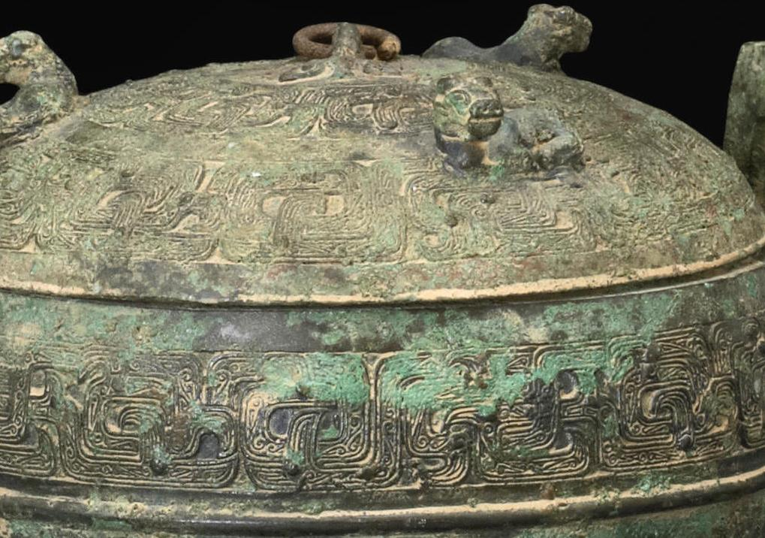

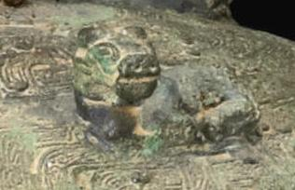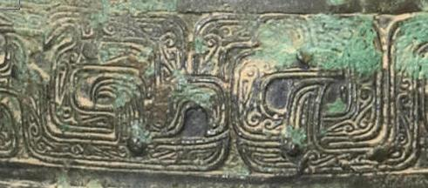

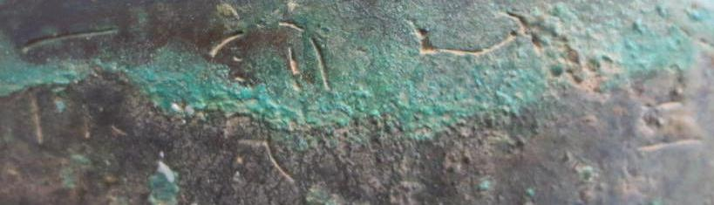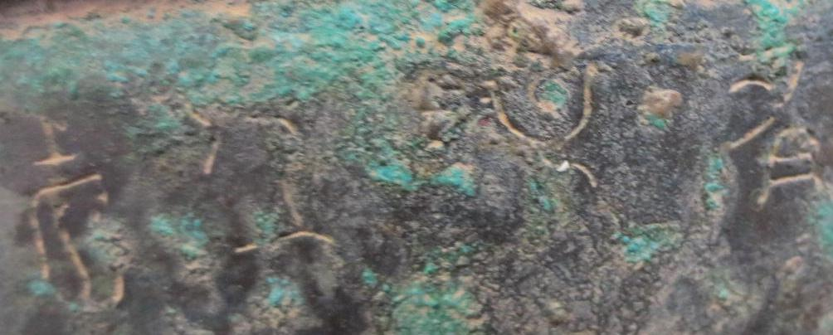

Asia-China-Bronze-W Han-Ding-206BCE- 24CE

Case No.: 5

**Accession No.**

**Formal Label:** Asia-China-Bronze-W Han-Ding-206BCE- 24CE

**Display Description:**

**LC Classification:**

**Date or Time Horizon:**

**Geographical Area:**

**Map:**

**GPS coordinates:**

**Cultural Affiliation:**

**Media: bronze**

**Dimensions:** *8in (20.3cm) width over handles  
6 1/2in (16.5cm) high*

**Weight:**

**Condition:**

**Provenance:**

Estimate:

US$ 40,000 - 60,000

#### Contacts

Angela Lee

San Francisco,

United States

Tel: +1 415 503 3358

Fax: +1 415 503 3300

[angela.lee@bonhams.com](mailto:angela.lee@bonhams.com?subject=Re:Lot 5198, Auction 20901, A cast bronze covered ding Western Han, 12 Mar 2013)

Auction Administration - Chinese Works of Art

Property from Various Owners

**Discussion:**

**References:**

* Provenance:  
  small paper label of Dimitri Emmanuel Gran Collection attached  
    
  Compare to an example in the Avery Brundage Collection, illustrated by Rene-Yvon Lefebvre d'Argence in *Bronze Vessels of Ancient China in The Avery Brundage Collection* (Japan, 1977), p.119, no. B60 B29+.